This is the Client’s review of the Smart City project as of the end of Sprint 1. This review is based on usability heuristics that outline different important aspects of UI and UX design.

Client Review

Jamie Kostaschuk

Brief:

Client review of website (through use of 10 usability heuristics (Nielsen, 2005)), and changes that should be made before end of sprint 2. Solely on the User Interface (UI) and User Experience (UX) of the system. Coding Quality will not be reviewed in this review.

# Visibility of system status:

*“The system should always keep users informed about what is going on, through appropriate feedback within reasonable time.”* (Nielsen, 2005).

In terms of system status, the primary areas of focus with the ‘status’ of the system for smart city that user should be able to see easily are:

* If they are currently logged in
* Their user type
* Their username
* The pages they are on at any point in time (such as home, map, etc.)

While the users can tell if they are logged, and the pages they are on (though the current Navbar shown below), the system does not provide easy access to other information to the user.

**NavBar showing that user is logged in and the page they are on:**

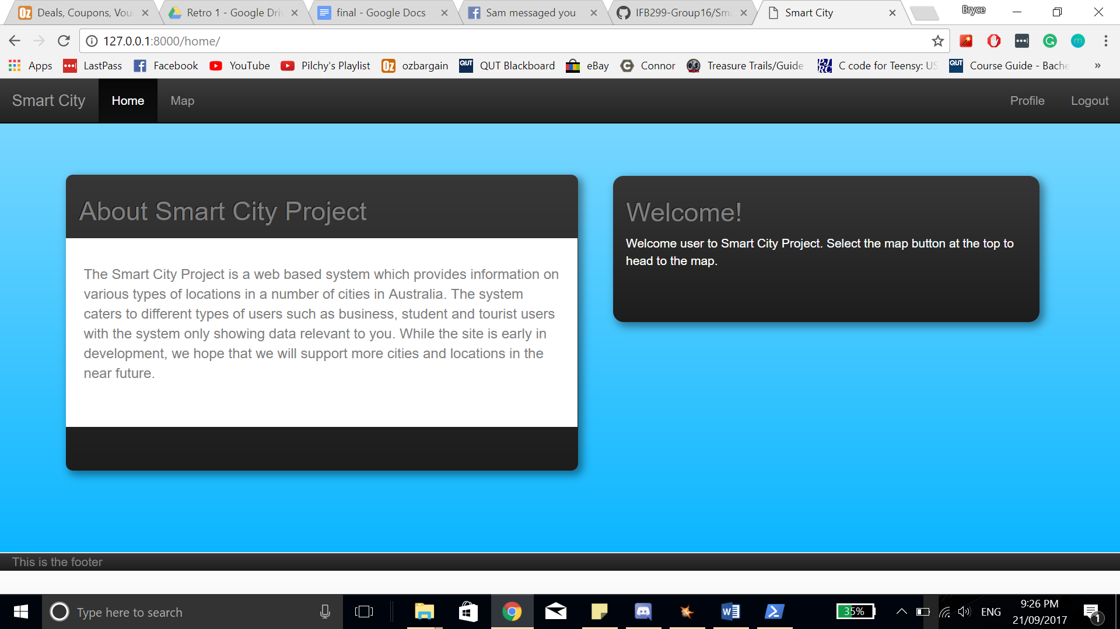

While at this stage of the development this won’t greatly impact the user experience, giving the user more feedback on the navigation bar about their user information (specifically their user type, username) would add more accessible information to users and benefit the user experience.

# Match between system and the real world:

*“The system should speak the users' language, with words, phrases and concepts familiar to the user, rather than system-oriented terms. Follow real-world conventions, making information appear in a natural and logical order.”* (Nielsen, 2005).

For the most part, the information and the language used on the webpages is acceptable and understandable for users, there are instances where the development team have still placed complex information in the webpages that would be cryptic to users, as shown below in the ‘Manage Your Profile’ section where there is the ‘algorithm’ section. Aspects such as this must be removed before the end of release one so real users can start using the webpage.   
**Manage Your Profile:**

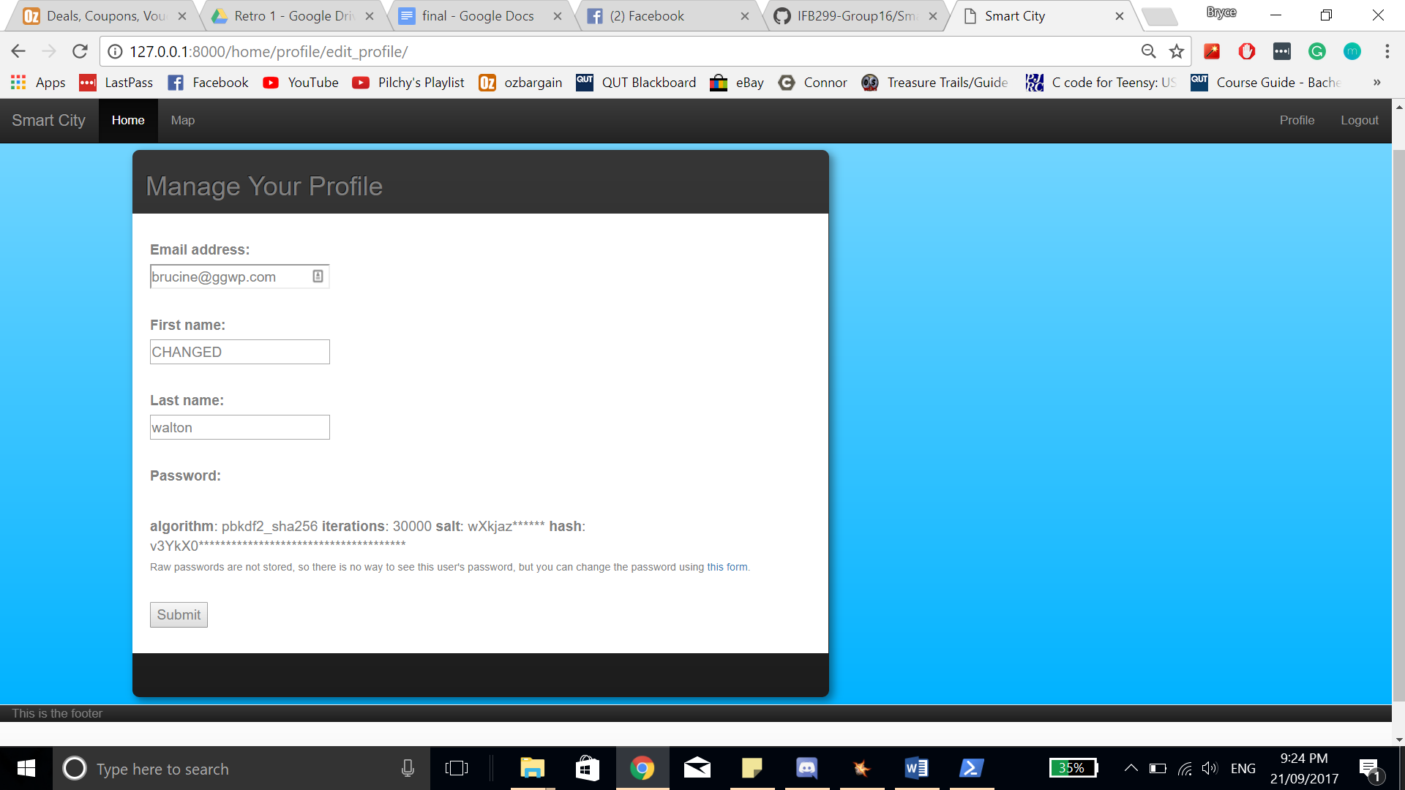

# User control and freedom:

*“Users often choose system functions by mistake and will need a clearly marked "emergency exit" to leave the unwanted state without having to go through an extended dialogue. Support undo and redo.”* (Nielsen, 2005).

At this stage, there is no ‘true’ user controls such as undo and redo. With that, there are only a handful of features at this point in the development, the fact that this is not implemented is acceptable for now until more features are added and the system is ready for real, live user testing.

# Consistency and standards:

*“Users should not have to wonder whether different words, situations, or actions mean the same thing. Follow platform conventions.”* (Nielsen, 2005).

There is consistency across the pages and the style. Notable the navigation bar remaining the same across the entire system. The best use of this is where the home page (unlogged in, logged in, and map page) have the same ‘2-box’ style. This style can be seen below.

**Not logged in home page:**

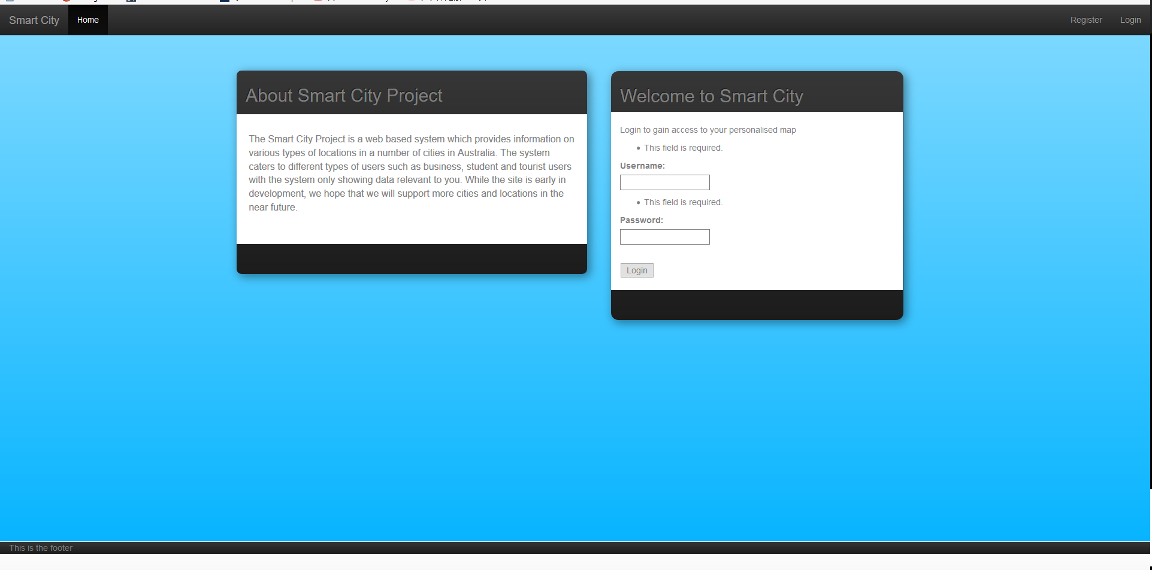

**Logged in home page:**

However, as seen in the images below, the Logged-in home page’s styling is not the same in the right had box. This should be changed to match the right-hand box’s styling before release.

There were some inconsistencies on the settings page, shown below. Where the website prompts users to “Manage Your profile” when the page’s function is for just viewing their information.

**Bad Heading for View Information Page:**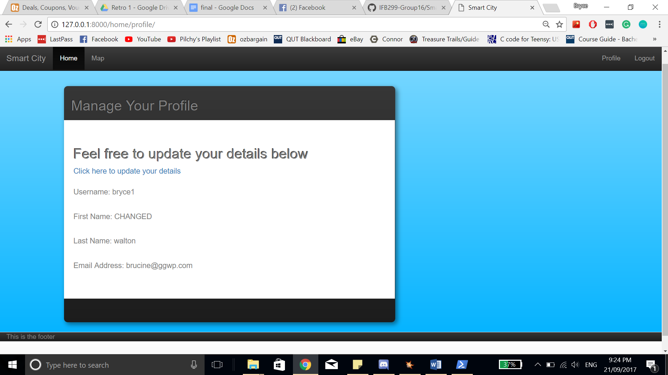

# Error prevention:

*“Even better than good error messages is a careful design which prevents a problem from occurring in the first place. Either eliminate error-prone conditions or check for them and present users with a confirmation option before they commit to the action.”* (Nielsen, 2005).

There are still errors throughout the system, this is to be expected for a non-released product. However as of writing the review, there are errors that are occurring, but are still unacceptable to have in the system. The most prominent example of this is that the system does not relocate the user when it doesn’t find a allocated page. The below picture’s error occurred when just typing 127.0.0.1:8000/. There should already be basic error prevention to stop simple errors such as this (redirecting users to the home page).

**Website Error Based on Url:**

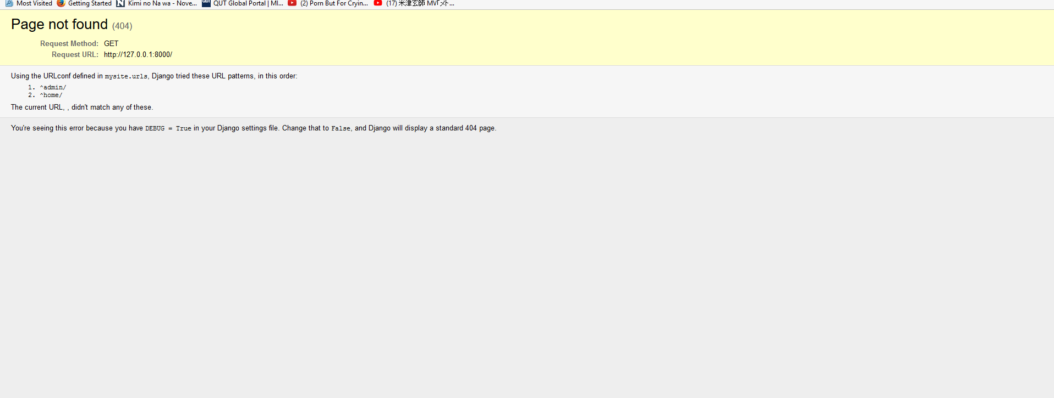

# Recognition rather than recall:

*“Minimize the user's memory load by making objects, actions, and options visible. The user should not have to remember information from one part of the dialogue to another. Instructions for use of the system should be visible or easily retrievable whenever appropriate.”* (Nielsen, 2005).

Due to the simplistic nature of the website at this point, the user’s ability to recognize and understand how to use the website is very high.

# Flexibility and efficiency of use:

*“Accelerators — unseen by the novice user — may often speed up the interaction for the expert user such that the system can cater to both inexperienced and experienced users. Allow users to tailor frequent actions.”* (Nielsen, 2005).

Accelerators:

The website makes effective use of accelerators for the solution. The most notable of these is the log in section embedded on the home page for unlogged in users.

However, when analyzing the system’s ability to ‘tailor’ actions or allowing the user to change functionality of the system to fit them, this isn’t implemented into the system. But these are considered ‘pleaser’ features that should be released after the core functionality of the system in release 1.

# Aesthetics and minimalist design:

*“Dialogues should not contain information which is irrelevant or rarely needed. Every extra unit of information in a dialogue competes with the relevant units of information and diminishes their relative visibility.”* (Nielsen, 2005).

While the website’s aesthetics are simplistic, compared to today’s standards in website design there is a large outdated aesthetic to the Smart City solution. The major areas that contribute to this are:

* The largely contrasting blue gradient background
* ‘shadows’ appearing below the aspect boxes (such as the welcome message on the home screen)

With the good, simplistic layout, the other aspects of the design should be altered to match today’s design standards of having a ‘’flatter’, more minimalistic appearance.

# Help users, recognize, diagnose and recover from errors:

*“*[*Error messages*](https://www.nngroup.com/articles/error-message-guidelines/) *should be expressed in plain language (no codes), precisely indicate the problem, and constructively suggest a solution.”* (Nielsen, 2005).

At the current early stage of the webpage there are errors that occur in the framework’s ‘debug’ mode (which is a feature that should be disabled before the solution goes live) there is no way for users to recover from these errors. This should be addressed at some point in the near future (possibly release 1 or 2).

On a positive, there is a certain level of error prevention in the system: such as refusing to allow a user to continue without filling out text boxes.

# Help and Documentation:

*“Even though it is better if the system can be used without documentation, it may be necessary to provide help and documentation. Any such information should be easy to search, focused on the user's task, list concrete steps to be carried out, and not be too large.”* (Nielsen, 2005).

At the current stage, there is no help and documentation sections provided to the users. Leading to potential user experience problems if the solution were to go live now after sprint 1.

# References:

Nielsen, J. (2005). *10 Heuristics for User Interface Design: Article by Jakob Nielsen*. [online] Nngroup.com. Available at: https://www.nngroup.com/articles/ten-usability-heuristics/ [Accessed 21 Sep. 2017].